Instalation and Configuration of MAMP:

The project and some of the labs need installation of the MAMP. It is important that you install and configure it as described in the following steps.

1. Download the MAP from the link:

<https://www.mamp.info/en/downloads/>

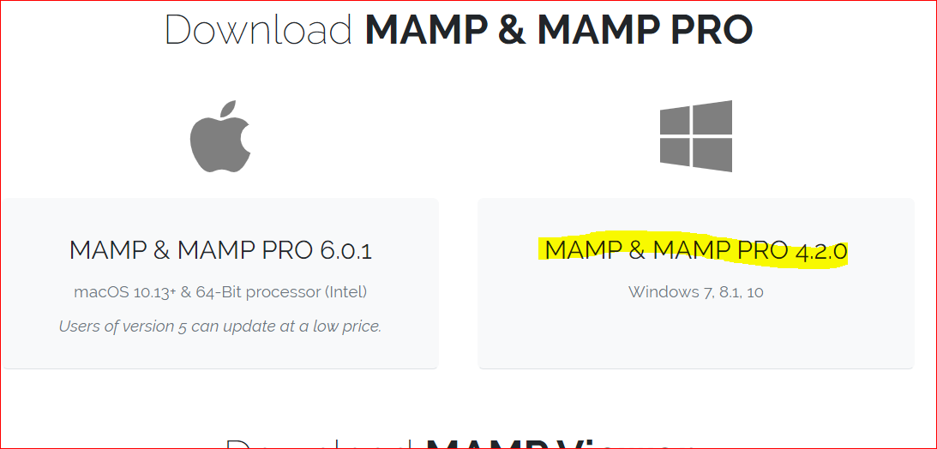

1. Install it on you computer with default steps
2. Configure the Port as describe below

* Click on MAMP

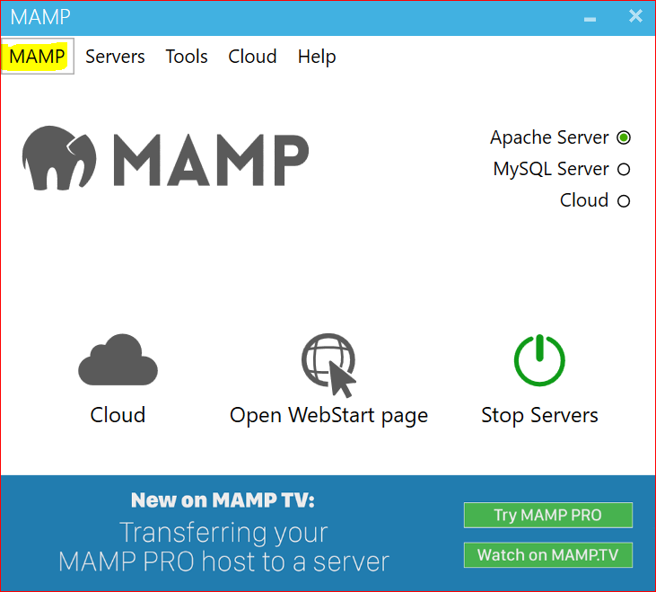

* Click on Preferences

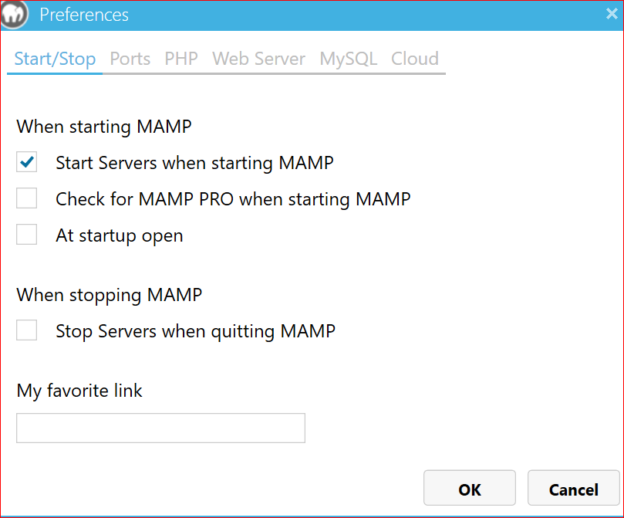

* Click on the port. Set the port number for Apache and click OK.

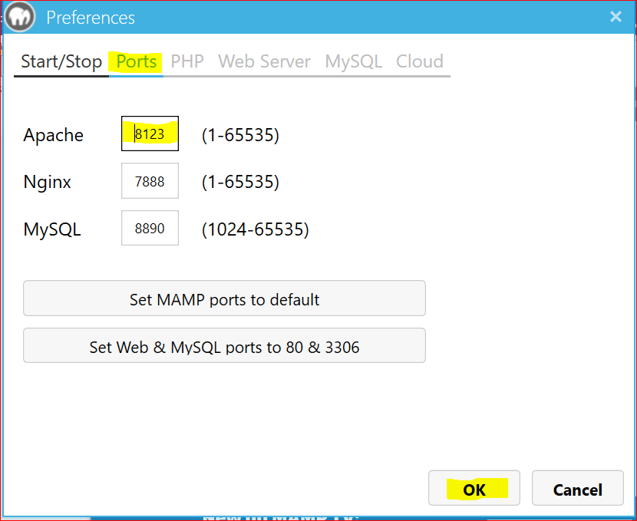

* Click on the start server

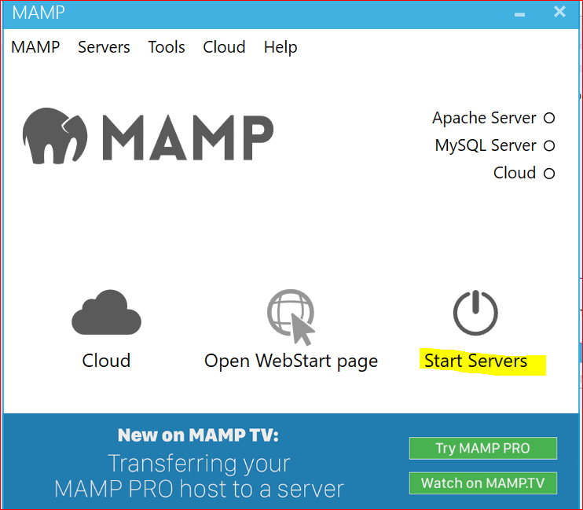

* It should look like following

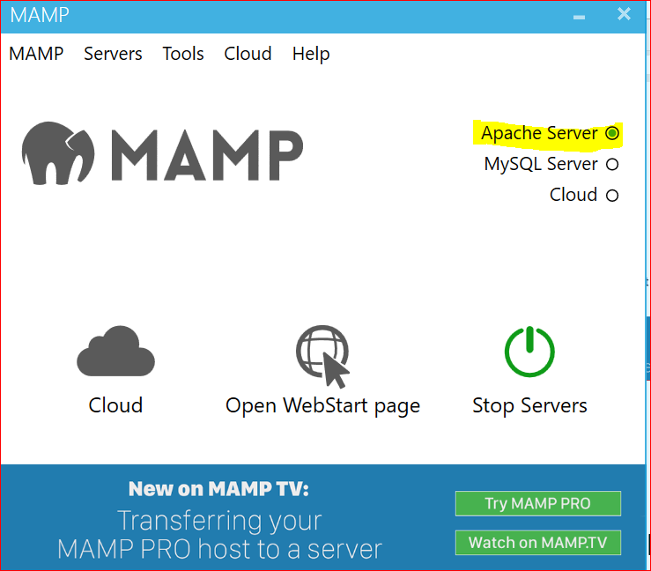

1. Now download the webpage testing.html and past it in the you C:\MAMP\htdocs folder

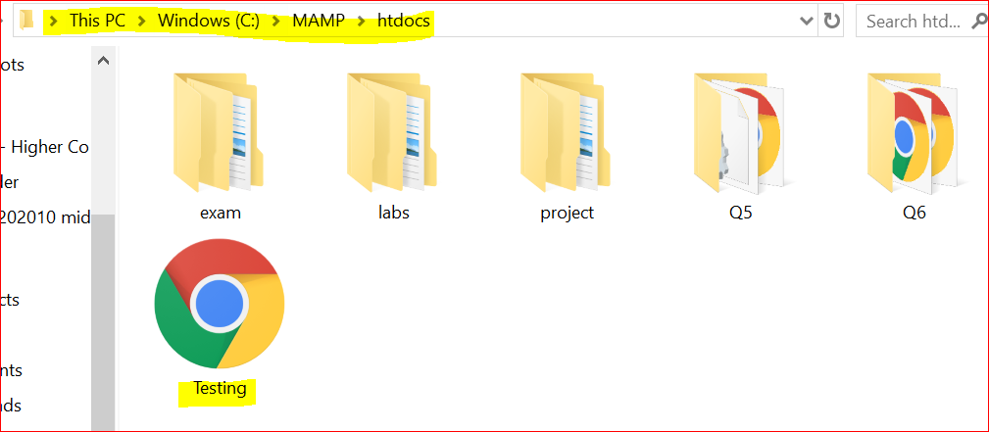

1. Open you default browser and type <http://localhost:8123/Testing.html>

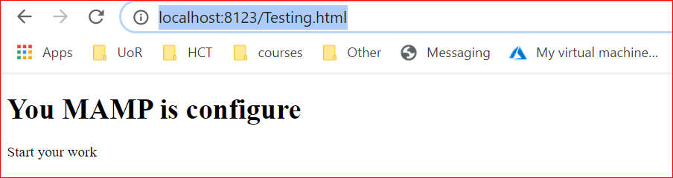

***Note: If you do not see the above page, ask you teacher for guidance***